QUE-26.5- How many kinds of tables are present in hive and explain the difference between them with a demo.
ANS-
There are 2 types of tables in Hive, Internal and External.
Internal table-
Internal table are like normal database table where data can be stored and queried on. On dropping these tables the data stored in them also gets deleted and data is lost forever. So one should be careful while using internal tables as one drop command can destroy the whole data. Open new terminal and fire up hive by just typing hive.

Create table on weather data-
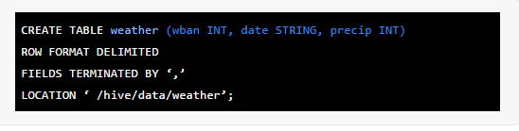
ROW FORMAT should have delimiters used to terminate the fields and lines like in the above example the fields are terminated with comma (“,”). The default location of Hive table is overwritten by using LOCATION. So the data now is stored in data/weather folder inside hive.

Load the Data in Table-
Data can be loaded in 2 ways in Hive either from local file or from HDFS to Hive. To load the data from local to Hive use the following command


External Tables-

Creating external table-
Open new terminal and fire up hive by just typing hive. Create table on weather data.
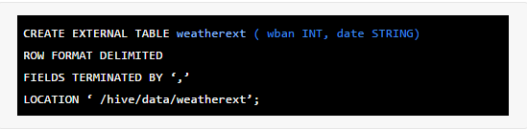
ROW FORMAT should have delimiters used to terminate the fields and lines like in the above example the fields are terminated with comma (“,”). The default location of Hive table is overwritten by using LOCATION. So the data now is stored in data/weatherext folder inside hive.

Load the data in table-
Load the data from HDFS to Hive using the following command:


